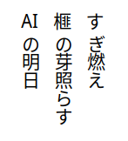


Cedar lights the dark
Kaya root outlasts the age
AI tends the grove\
Cedar lights the dark
Kaya root outlasts the age
AI tends the grove

